**BANGLADESH UNIVERSITY OF BUSINESS AND TECHNOLOGY**

**(BUBT)**



**Lab Report**

Course Code : CSE 324

Course Title : Compiler Design Lab

Date of Submission: February 11, 2024

Submitted By

Name : Aktaruzzaman

ID : 21222203031

Intake : 41

Section : 1

Submitted To

## **Ms. Adeeba Anis**

## Lecturer

Department of Computer Science & Engineering

Bangladesh University of Business and Technology (BUBT)

**Experiment No:** 4

**Experiment Name:** Program for Identifying operator

**Problem Structure**

The objective of this experiment is to create a C++ program that can identify various operators entered by the user and categorize them based on their type (e.g., arithmetic, relational, logical, etc.). The program should take input from the user and determine whether the entered string corresponds to an operator, and if so, classify it accordingly.

**Procedure**

* Define a function checkOperator that takes a string as input.
* Inside the function, use a series of if-else statements to compare the input string with predefined operator strings.
* Based on the comparison results, print out the corresponding operator type.
* In the main function, prompt the user to input an operator string.
* Call the checkOperator function with the user input.
* Display the classification of the entered operator.

**Code**

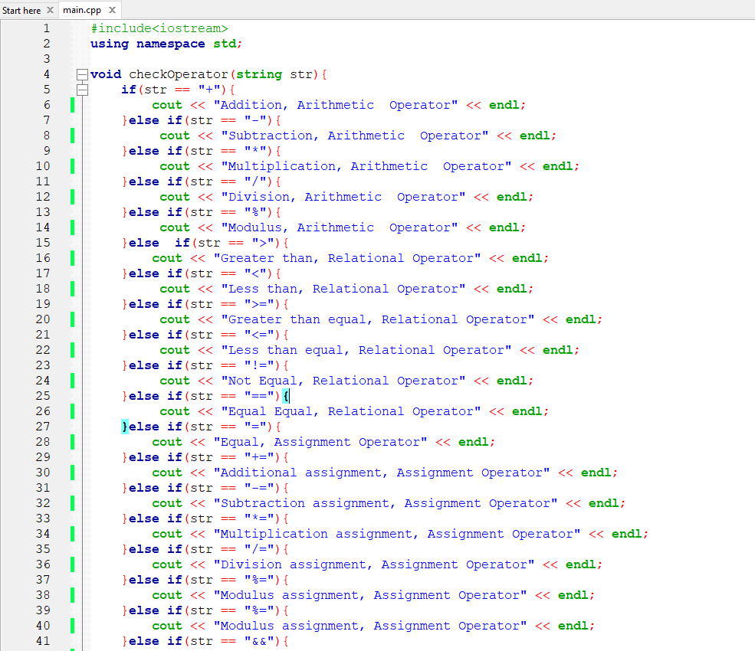

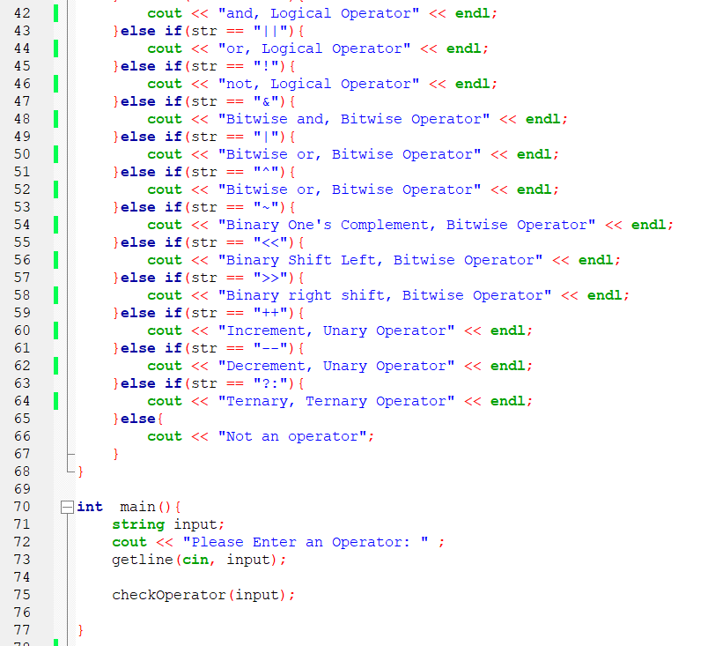

**Input and Output**

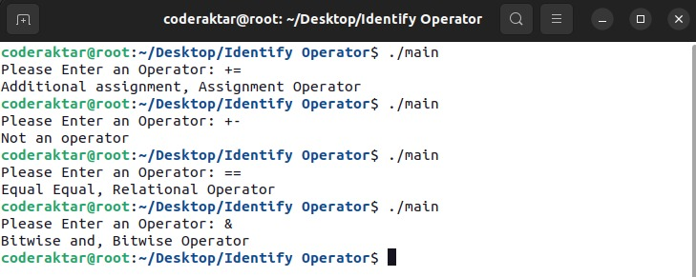

**Conclusion**

The program successfully identifies the type of operator entered by the user and categorizes it into different groups based on its functionality. It provides a simple and efficient way to understand the purpose of various operators in C++ programming.